---------------------------------------------------------------------

-- LAB 05

--

-- Exercise 3

---------------------------------------------------------------------

USE TSQL;

GO

---------------------------------------------------------------------

-- Task 1

--

--

-- Write a SELECT statement against the Sales.Orders table and retrieve the orderid and orderdate columns.

-- Retrieve the 20 most recent orders, ordered by orderdate.

--

-- Execute the written statement and compare the results that you got with the recommended result shown in the file 72 - Lab Exercise 3 - Task 1 Result.txt.

---------------------------------------------------------------------

---------------------------------------------------------------------

-- Detyre 1

--

--

1-- Selektoni kolonat orderid dhe orderdate nga tabela Sales.Orders.

2-- Nxjerr 20 porosite me te fundit, te radhitura sipas orderdate.

--

3-- Ekzekuto veprimet dhe krahaso rezultatet qe moret me rezultatet e rekomanduara ne dokumentin 72 –

Lab Exercise 3 - Task 1 Result.txt.

---------------------------------------------------------------------

1&2--

Select TOP(20) o.orderid , o.orderdate

From Sales.Orders o

Order By o.orderdate DESC

-- Afisho të gjitha porositë duke u nisur nga veprimet më të fundit

Select o.orderid , o.orderdate

From Sales.Orders o

Order By o.orderdate DESC

3--

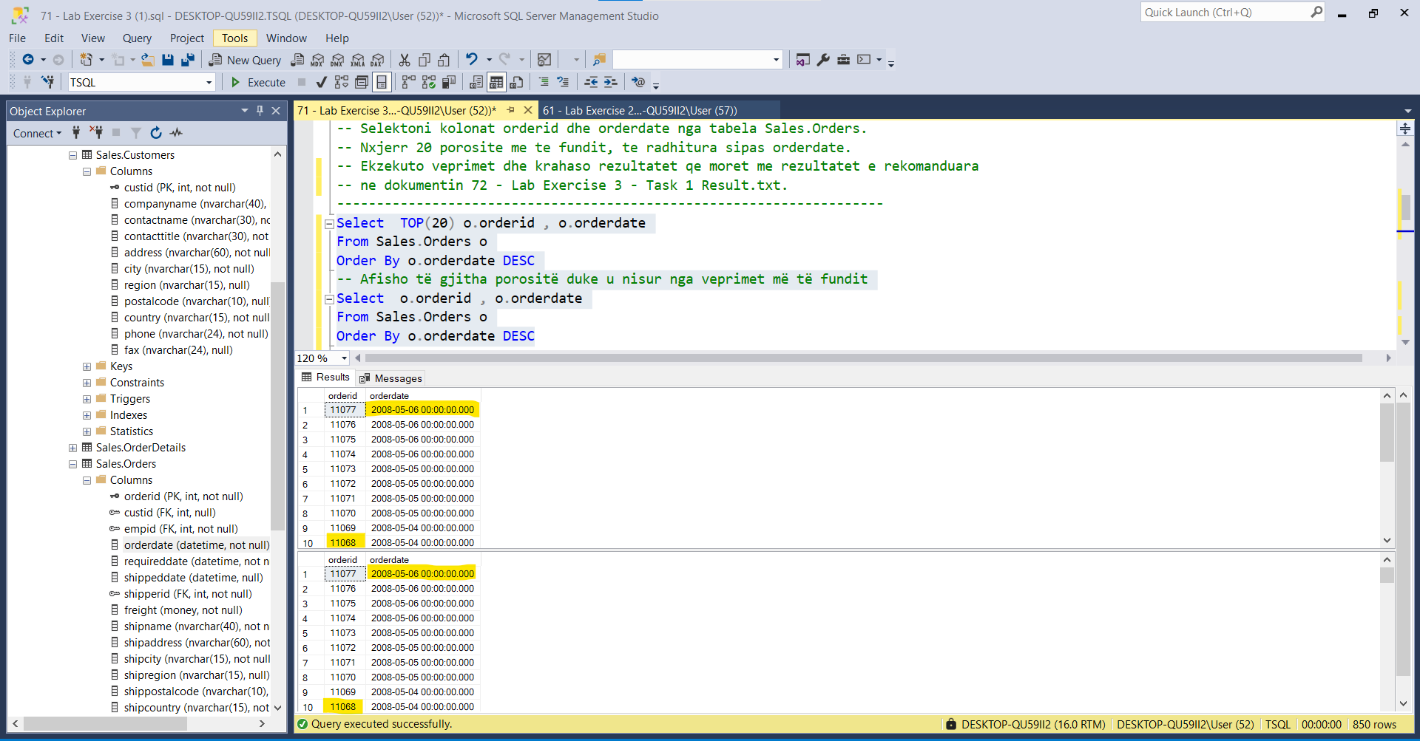

\*\*\*Edhe vlerat e tjera të querisë së parë gjenden edhe në querinë e dytë

---------------------------------------------------------------------

-- Task 2

--

1-- Write a SELECT statement to retrieve the same result as in task 1, but use the OFFSET-FETCH

clause.

--

2-- Execute the written statement and compare the results that you got with the results from task 1.

---------------------------------------------------------------------

---------------------------------------------------------------------

-- Detyra 2

--

1-- Realizoni te njejtat veprime si ne Detyren 1, por perdorni OFFSET-FETCH clause.

--

2-- Ekzekuto veprimet dhe krahaso rezultatet qe moret me rezultatet nga Detyra 1.

---------------------------------------------------------------------

1--

Select o.orderid , o.orderdate

From Sales.Orders o

Order By o.orderdate DESC

OFFSET 20 ROWS FETCH NEXT 20 ROWS ONLY

2--

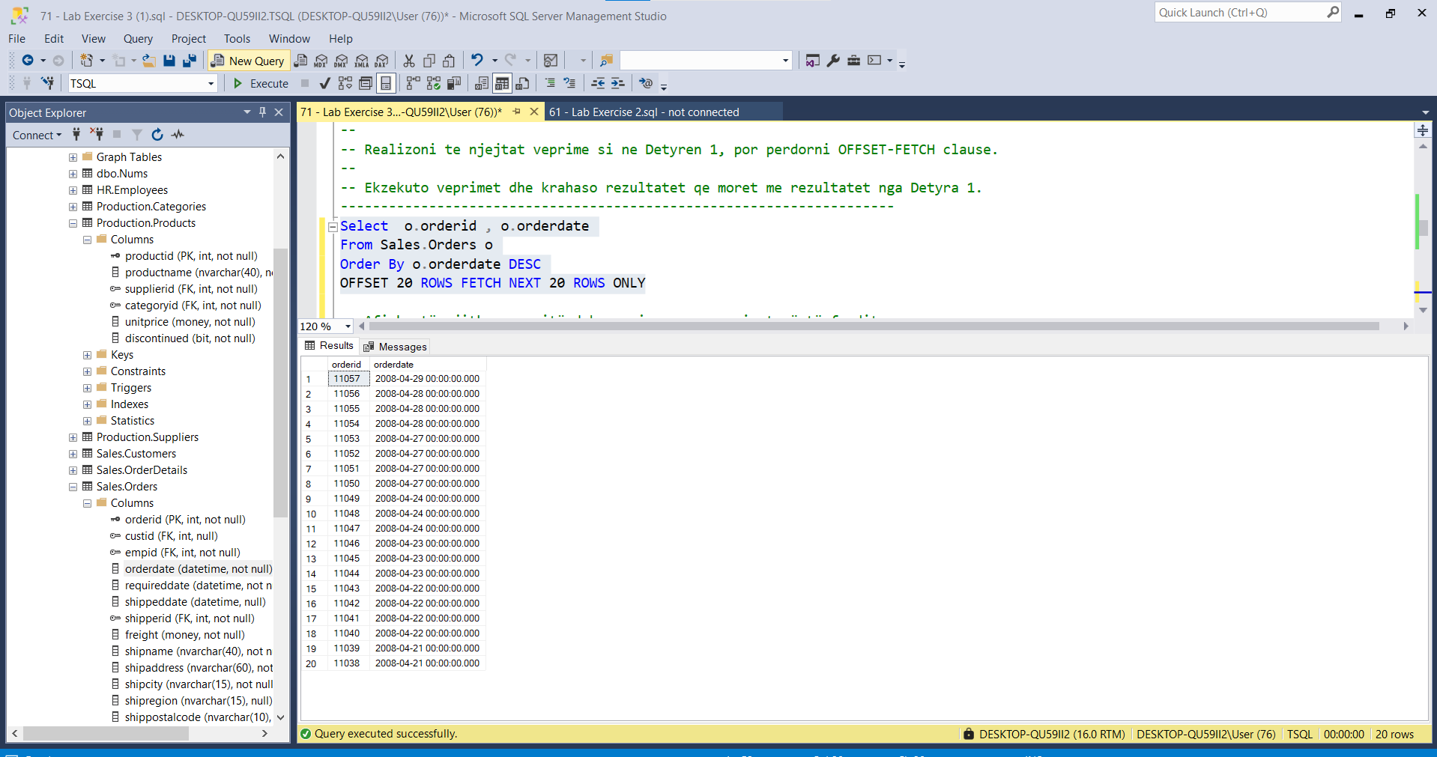

---------------------------------------------------------------------

-- Task 3

--

1-- Write a SELECT statement to retrieve the productname and unitprice columns from the

Production.Products table.

--

2-- Execute the T-SQL statement and notice the number of the rows returned.

--

3-- Modify the SELECT statement to include only the top 10 percent of products based on unitprice

ordering.

--

4-- Execute the written statement and compare the results that you got with the recommended result

shown in the file 73 - Lab Exercise 3 - Task 2 Result.txt. Notice the number of rows returned.

--

5-- Is it possible to implement this task with the OFFSET-FETCH clause?

---------------------------------------------------------------------

---------------------------------------------------------------------

-- Detyra 3

--

1-- Selektoni kolonat productname dhe unitprice nga tabela Production.Products.

--

2-- Ekzekuto kodin T-SQL dhe vini re numrin e rrjeshtave qe u kthyen.

--

3-- Modifiko kodin qe te perfshije vetem 10 perqind te produkteve me te mira duke u bazuar ne

unitprice ordering.

--

4-- Ekzekuto veprimet dhe krahaso rezultatet qe moret me rezultatet e rekomanduara ne dokumentin 73 -

Lab Exercise 3 - Task 2 Result.txt. Notice the number of rows returned.

--

5-- A eshte e mundur te implementohet kjo detyre me OFFSET-FETCH clause?

---------------------------------------------------------------------

1--

select p.productname,p.unitprice

from Production.Products p

2--

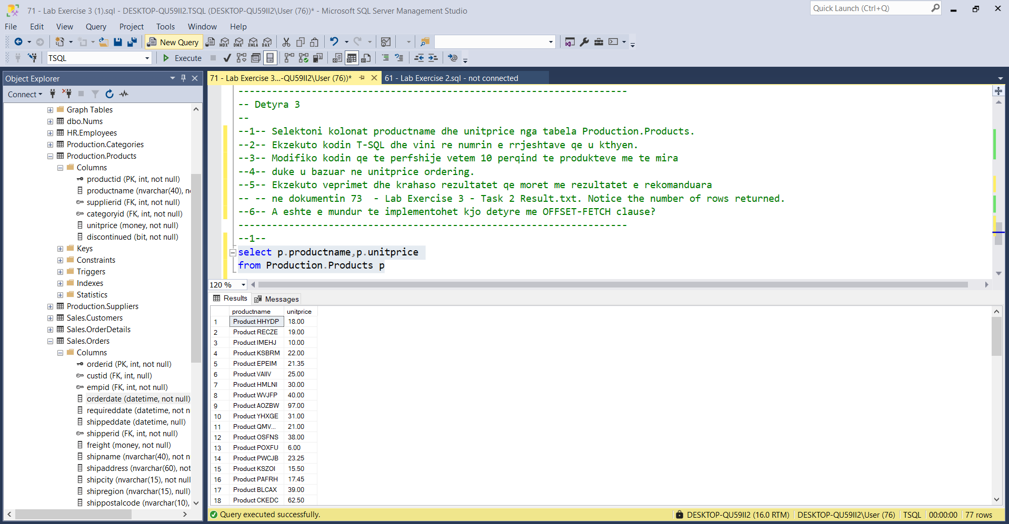

3--

Select TOP(10) PERCENT p.productname,p.unitprice

From Production.Products p

Order by p.unitprice DESC

4—Tek Task2 u gjeneruan 20 ose 10 rreshta sipas rastit ne fjale , ndersa ketu 8 rreshta

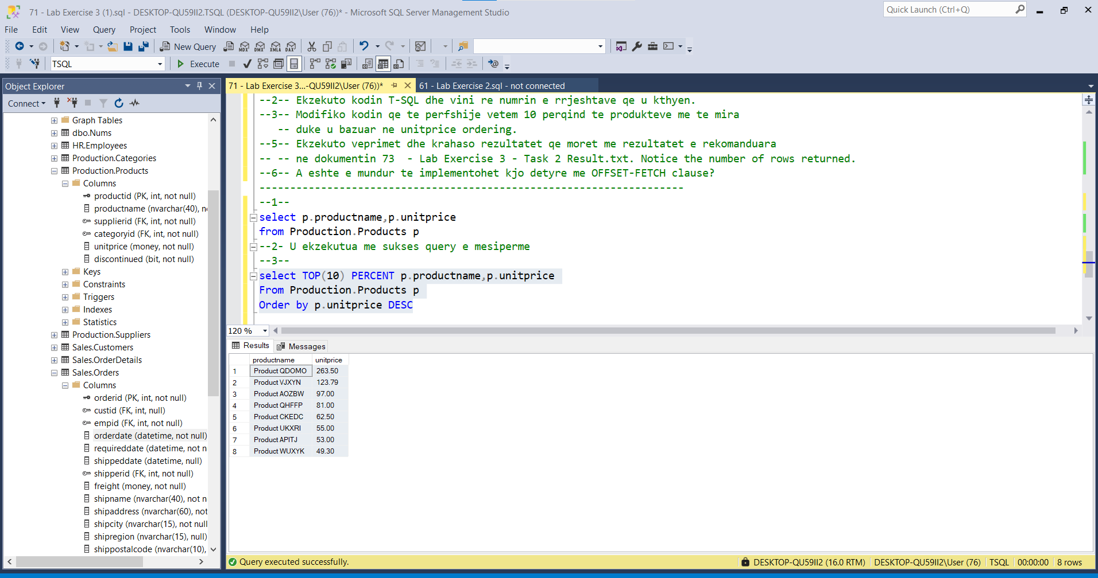

5--

